AFRIRESQ
How the system is supposed to work
One account. Medical help is the full path. Every other emergency stays in the same app, on a shorter path. The map lives inside the case.
This document is the shared picture of the system we are rebuilding. It describes the product, not a screen-by-screen design. The logo and the high-fidelity screens come after this model stays agreed.

The idea
AfriResQ helps a person in Uganda reach care. They open one app, say what is happening, and share where they are. The app then offers a real next step: a hospital that can send an ambulance, a route so they can go themselves, or a desk for a different kind of emergency.
Medical help is the strongest part of the product, in the same way medicine is the course Makerere is known for, and computing is the course ISBAT is known for. The app still carries other emergencies. Those other types use the same account, the same location, and the same case. They do not pretend to dispatch a medical ambulance.
AfriResQ sits beside the national emergency lines. 999 and 112 stay one tap away on every important screen. The app does not replace them.

The diagram
Read the chart from top to bottom. Citizen and student are two doors into the same profile. Home leads with medical. From a medical report the person can open their university hospital, look for the nearest place, or go there themselves. An ambulance appears only when that place is connected. Other emergency types leave Home and go to their own desk. Every path ends in one live case, then closes.
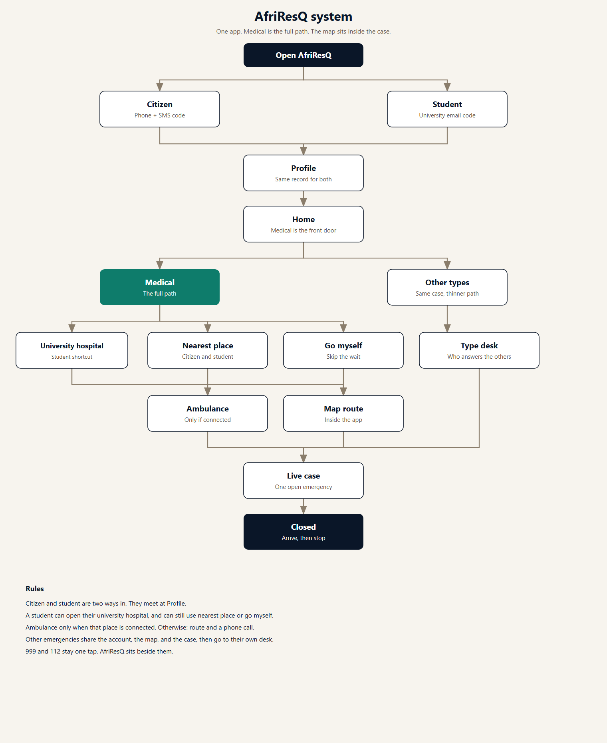
Figure 1. AfriResQ system diagram. Medical is marked in green because it is the full path.

Two ways to create an account
There is one product. Citizen and student are two ways to join, not two apps. After the code is confirmed, both people fill the same profile.

Citizen
A citizen signs up with a Uganda phone number. AfriResQ sends a code by SMS. The number is confirmed before the account exists. The same phone is used later to sign in, and it is the number a hospital desk or ambulance crew can call.

Student
A student first chooses a university from the directory. Every university we intend to cover is listed. Only a university that is live can finish signup. The others stay visible and are marked coming soon, so the list does not look empty and nobody is turned away without an explanation.
The student then enters their university email. A code is sent to that inbox. The address must belong to that university. For Makerere, the address ends in mak.ac.ug. The email proves they are a student of that university. They still save a phone number on the profile, because email is not how a crew reaches someone at the roadside.
A verified student sees their own university hospital first. That is a shortcut, not a lock. Nearest place and go-myself stay on the same screen. A citizen uses the same map and can see the same hospitals. A citizen does not get a “my university” pin.

The profile
The profile is filled once, right after the code, and it is what the person sees later under Profile. It exists so help can still act if the person cannot speak for themselves.
What we keep | Citizen | Student | When it is used
Full name | Required | Required | On the case and with the desk
Phone | Confirmed by SMS at signup | Required on the profile | The desk or crew calls this number
Email | Optional | University email, confirmed by code | Proves the student
University | — | Chosen from the directory | Pins their hospital
Student number | — | Required | The desk can prepare
Campus hall or residence | — | Asked | Helps when GPS is weak
Next of kin | Name, relationship, phone | The same | If the person cannot answer
Home location | A saved pin | A saved pin | Used when GPS fails
Blood, allergies, conditions, medications | Asked, and can be skipped | The same | Sent only during an open case
Share medical card | On, and can be turned off | The same | Stops when the case closes
Language | Asked | Asked | Screens and phone calls
The medical card is not a public profile. It travels only with an open case, and only to the place handling that case. When the case closes, sharing stops.

Home
After the profile is saved, the person lands on Home. Medical help is the front door: the largest action on the screen. Other emergency types are on the same screen, smaller. A student also sees a card for their university hospital, with distance and whether an ambulance can be sent. A citizen sees their saved home location and the way into nearest help.
The other types on Home are road accident, fire, security, missing person, disaster, and other. Choosing one of them does not open the medical ambulance flow.

A medical emergency
This is the path we design completely. The report asks four things.
- What is happening: not breathing, unconscious, severe bleeding, injury or fall, chest pain, pregnancy, seizure, or other medical.
- Whether the person is awake: yes, no, or not sure. If the answer is no, the screen recommends an ambulance and still shows 999 or 112.
- Who needs help: the person using the phone, or someone with them.
- Where they are: live GPS, the saved home pin, or a written place such as a building, a room, and a landmark.
From there the person chooses how to get help. Three choices sit side by side.

University hospital
Only a verified student sees this as their own hospital. It is listed first. If that hospital is connected, the student can ask it to send an ambulance, or tell the desk they are on the way. The student details needed for preparation go with that request. The student can still ignore this shortcut and pick any other place.

Nearest place
Citizen and student share this. The map shows places, nearest first. Each place is either connected or only listed.
Kind of place | What the person can do
Connected hospital | Call, follow a route, or request an ambulance
Listed hospital | Call and follow a route. AfriResQ cannot dispatch from there
University hospital | A student shortcut. It is still either connected or listed
Other desk | Fire, security, and the rest. Same case, no medical ambulance
The list can be filtered: all places, places with an ambulance, or places under a set distance. If a filter matches nothing, the screen says so and offers All again.

Go there myself
The person can leave without waiting. The map inside AfriResQ draws the route, the distance, and the expected time. Starting the route tells a connected place that the person is coming. A listed place asks them to call ahead, and the screen says plainly that dispatch is not available. They can switch from the route to an ambulance only if that place is connected.

The ambulance
An ambulance is offered only by a connected place. The request goes to that hospital’s desk. The person sees the request sent, then a crew that has accepted, then the vehicle moving on the map with a falling arrival time. They can share live location, call the crew, or cancel until the crew arrives. Cancelling does not remove the option to go themselves.
A place that is not connected never shows a send-ambulance button. It shows the phone number and the route, and it says that AfriResQ cannot dispatch from there.

The map
The map is part of AfriResQ. It is not a link out to another app. On a case it can show:
- The person, from live GPS.
- The saved home pin, used when GPS fails.
- Hospitals and other places, with connected places marked differently from listed ones.
- The university hospital, highlighted for a verified student.
- The chosen route, with distance, time, and the next instruction.
- The ambulance, once a crew is on the way.
Live location is shared only while a case is open, and only with the desk or crew on that case.

Other emergencies
Road accident, fire, security, missing person, disaster, and other use the same account, the same location capture, the same map, and the same case record. They do not borrow the medical ambulance.
Each type is meant to reach a desk registered for that type. The desk sees the case, the location, and the profile details allowed for that case. They accept it, call, or mark it handled. Until a desk for that type is connected, the screen still keeps the case, shows the route if there is a place to go, and keeps 999 and 112 one tap away. A report with nobody able to accept it would only be a form, so the desk is part of the system, not a later extra.

One case, from send to close
Sending help, starting a route, or sending another emergency type opens one case. The case holds the type, the place, the path (ambulance, self, or desk), the location, and the time.
State | What is true
Sent | The place or desk has the report and the location
Accepted | A desk or a crew has taken the case
On the way | An ambulance is moving, or the person is following the route
Arrived | The crew is there, or the person has arrived
Closed | A short rating can be left. Live location and medical sharing stop
The person can cancel before arrival. After close, the profile and the home location stay for the next time. The case number, the type, the place, and the time remain on the closed case so there is a record.

Rules that keep the system in one piece
Rule | Why it is in the model
A student still saves a phone number | Email proves the university. The phone is how help reaches them.
The university hospital is a shortcut, not a lock | Nearest place and go-myself stay on the same medical screen.
Citizens use the same map | They see the same hospitals. They do not get a university pin.
An ambulance only comes from a connected place | A listed place offers a route and a phone call, and says so.
Other types do not borrow the ambulance | They share the account, the map, and the case, then go to their own desk.
A desk is part of the system | Someone has to accept the case.
The medical card travels only with an open case | It is not a public profile, and sharing stops when the case closes.
Home location is stored | A report still works when GPS fails.
999 and 112 stay one tap | AfriResQ sits beside the national lines.

What we build next
This document fixes the structure. The next design work is a proper logo, then the screens, with the medical path drawn first: signup, profile, Home, the report, the map, the ambulance, and the closed case. Student signup and the university hospital are part of that first path, because they change what Home shows. The other emergency types stay in the product, on the thinner path described above.

